

Worksheet-2: C++ Basics

Submitted by – James Limbu

Submitted to - Aashish Acharya

Task 1 : 30 marks
1. Create a Time class to store hours and minutes. Implement:
1. Overload the + operator to add two Time objects
2. Overload the > operator to compare two Time objects
3. Handle invalid time (>24 hours or >60 minutes) by throwing a custom exception
#include <iostream>
using namespace std;

class InvalidTimeException : public exception {
public:
const char* what() const throw() {
return "Error: Time must be between 00:00 and 23:59";
}
};

class Time {
private:
int hours;
int minutes;

void normalize() {
hours += minutes / 60;
minutes %= 60;
hours %= 24;
}

public:
Time(int h = 0, int m = 0) {
if (h < 0 || h >= 24 || m < 0 || m >= 60) {
throw InvalidTimeException();
}
hours = h;
minutes = m;
}

Time operator+(const Time& other) const {
Time temp(hours + other.hours, minutes + other.minutes);
temp.normalize();
return temp;
}

bool operator>(const Time& other) const {
return (hours > other.hours) ||
(hours == other.hours && minutes > other.minutes);
}

void display() const {
if (hours < 10) cout << "0";
cout << hours << ":";
if (minutes < 10) cout << "0";
cout << minutes;
}

static Time getTimeFromUser(const char* prompt) {
int h, m;
char sep;
cout << prompt;
cin >> h >> sep >> m;

if (cin.fail() || sep != ':') {8
throw runtime_error("Invalid input format. Please use HH:MM.");
}

return Time(h, m);
}
};

int main() {
try {
cout << "Time Calculator\n";
cout << "---------------\n";

Time time1 = Time::getTimeFromUser("Enter first time (HH:MM): ");
Time time2 = Time::getTimeFromUser("Enter second time (HH:MM): ");

cout << "\nResults:\n";
cout << "--------\n";

cout << "First time: ";
time1.display();
cout << "\n";

cout << "Second time: ";
time2.display();
cout << "\n";

Time total = time1 + time2;
cout << "Total time: ";
total.display();
cout << "\n";

cout << "Comparison: ";
if (time1 > time2) {
time1.display();
cout << " is later than ";
time2.display();
} else {
time2.display();
cout << " is later than ";
time1.display();
}
cout << "\n";
}
catch (InvalidTimeException& e) {
cerr << "\n" << e.what() << "\n";
}
catch (...) {
cerr << "\nError: Invalid input format. Please enter time as HH:MM\n";
}

return 0;
}
Output:
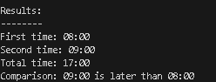
1. If the user put time in proper format.
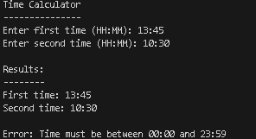
2. if the user put time more that 24hr.

Task 2
1. Create a base class Vehicle and two derived classes Car and Bike:
1. Vehicle has registration number and color
2. Car adds number of seats
3. Bike adds engine capacity
4. Each class should have its own method to write its details to a file
5. Include proper inheritance and method overriding
#include <iostream>
#include <fstream>
#include <string>
using namespace std;
class Vehicle {
protected:
string registrationNumber;
string color;

public:
Vehicle(const string& regNum, const string& clr)
: registrationNumber(regNum), color(clr) {}

virtual void writeToFile(ofstream& outFile) const {
outFile << "Vehicle Details:\n";
outFile << "Registration Number: " << registrationNumber << "\n";
outFile << "Color: " << color << "\n";
}

virtual ~Vehicle() {}
};

class Car : public Vehicle {
private:
int numberOfSeats;
public:
Car(const string& regNum, const string& clr, int seats)
: Vehicle(regNum, clr), numberOfSeats(seats) {}

void writeToFile(ofstream& outFile) const override {
Vehicle::writeToFile(outFile);
outFile << "Type: Car\n";
outFile << "Number of Seats: " << numberOfSeats << "\n\n";
}
};
class Bike : public Vehicle {
private:
int engineCapacity;
public:
Bike(const string& regNum, const string& clr, int capacity)
: Vehicle(regNum, clr), engineCapacity(capacity) {}

void writeToFile(ofstream& outFile) const override {
Vehicle::writeToFile(outFile);
outFile << "Type: Bike\n";
outFile << "Engine Capacity: " << engineCapacity << "cc\n\n";
}
};
int main() {

Car myCar("Hyundai", "Red", 5);
Bike myBike("Ducati", "Black", 150);
ofstream outFile("wew.txt");
if (!outFile) {
cerr << "Error opening file for writing!\n";
return 1;
}
myCar.writeToFile(outFile);
myBike.writeToFile(outFile);
outFile.close();
cout << "Vehicle details have been written to vehicles.txt\n";
return 0;
}
Output:
1. Output of the code when saved.
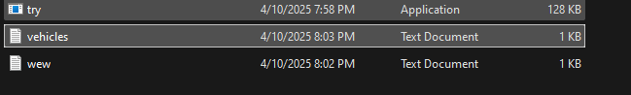
2. txt file created to save vehicle details.
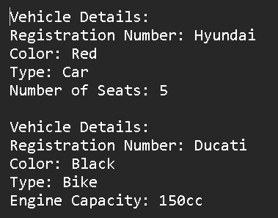
3. details of saved vehicles

2. Create a program that:
1. Reads student records (roll, name, marks) from a text file
2. Throws an exception if marks are not between 0 and 100
3. Allows adding new records with proper validation
4. Saves modified records back to file
#include <iostream>
#include <fstream>
using namespace std;
struct Student {
int roll;
string name;
int marks;
};

bool validateMarks(int marks) {
if (marks < 0 || marks > 100) {
cout << "Invalid marks! Must be between 0-100.\n";
return false;
}
return true;
}

void displayStudents(Student students[], int count) {
cout << "\nCurrent Students:\n";
for (int i = 0; i < count; i++) {
cout << "Roll: " << students[i].roll
<< ", Name: " << students[i].name
<< ", Marks: " << students[i].marks << endl;
}
}

int main() {
const string filename = "students.txt";
const int MAX_STUDENTS = 100;
Student students[MAX_STUDENTS];
int count = 0;
ifstream inFile(filename);
if (inFile) {
while (inFile >> students[count].roll >> ws &&
getline(inFile, students[count].name, ',') &&
inFile >> students[count].marks) {
count++;
}
inFile.close();
}
displayStudents(students, count);
char choice;
do {
cout << "\nAdd new student? (y/n): ";
cin >> choice;

if (tolower(choice) == 'y') {
if (count >= MAX_STUDENTS) {
cout << "Maximum students reached!\n";
break;
}

cout << "Enter roll number: ";
cin >> students[count].roll;

cout << "Enter name: ";
cin.ignore(); // Clear input buffer
getline(cin, students[count].name);

cout << "Enter marks (0-100): ";
cin >> students[count].marks;

if (validateMarks(students[count].marks)) {
count++;
}
}
} while (tolower(choice) == 'y');

ofstream outFile(filename);
for (int i = 0; i < count; i++) {
outFile << students[i].roll << " "
<< students[i].name << ","
<< students[i].marks << endl;
}
outFile.close();
cout << "\nRecords saved to file. Goodbye!\n";
return 0;
}
Outputs:
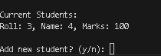
1. Output after adding student by user.
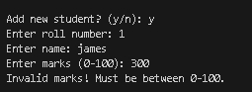
2. Output when user exceeds the number of 100.
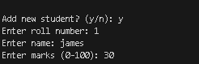
3. Output when student is added successfully.
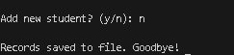
4. Output when user exits from the code.
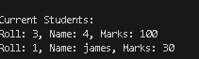
5. Output of students saved by the user.

